Project Design Phase-II:
Data Flow Diagram & User Stories

Parameter | Details
Date | 08 March 2026
Team ID
Project Name | VoltEdge: EV Analytics Portal
Maximum Marks | 4 Marks

1. Data Flow Diagram (DFD)
A Data Flow Diagram (DFD) is a traditional visual representation of the information flows within a system. It shows how data enters and leaves the system, what changes the information, and where data is stored.
VoltEdge System Flow:
- Data Ingestion: User selects the raw EV dataset (CSV) to process and load.
- PostgreSQL Processing: The raw data is cleaned and stored in the public.Tables schema (e.g., electric_car_data_clean).
- Tableau Integration: Cleaned data is extracted from PostgreSQL and passed to Tableau for visualization.
- Flask Presentation: The final interactive dashboards are visualized in the web UI for the end-user.
Note for Word File: You should insert a screenshot of your specific DFD here. Based on the "Simplified Flow" in your template, your DFD should show the flow from PostgreSQL (Storage) $\rightarrow$ Tableau (Processing) $\rightarrow$ Flask Web App (Presentation).

- This diagram shows the high-level flow of information through your entire system, from data collection to final visualization.
How to use: Paste this image into Section 1 (Data Flow Diagram) of your Word file.
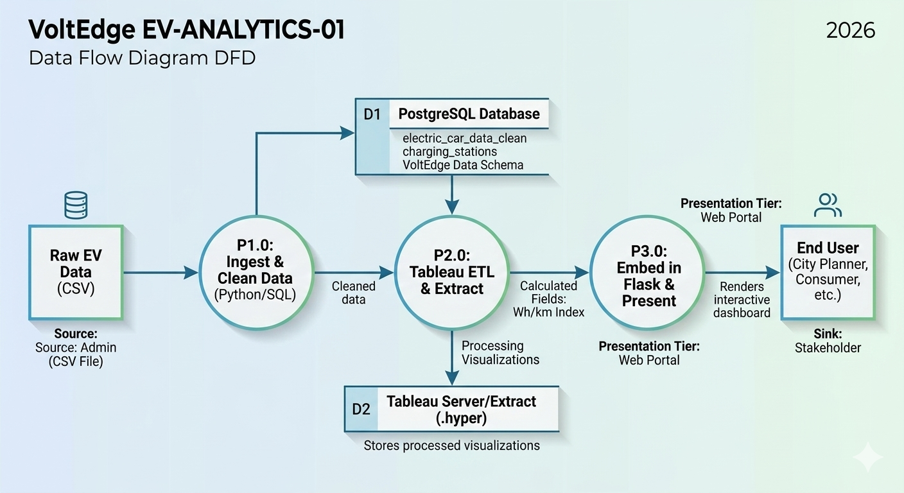
Image Summary: This DFD follows the standard 3-Tier architecture: Data (PostgreSQL) is cleaned (Process 1.0), extracted by Tableau (Process 2.0), and then embedded into the Flask web server (Process 3.0) for the user to view.

2. User Stories
Use the below template to list the user stories for the VoltEdge platform.
User Type | Functional Requirement (Epic) | User Story Number | User Story / Task | Acceptance Criteria | Priority | Release
Eco-Consumer | Data Exploration | USN-1 | As a user, I can filter EVs by brand and body style to find a car that fits my needs. | I can see the list update instantly based on my filters. | High | Sprint-1
Eco-Consumer | Cost Analysis | USN-2 | As a user, I can view the "Price-to-Range" ratio to find the most cost-effective EV. | The dashboard displays a "Best Value" ranking. | High | Sprint-1
City Planner | Infrastructure Mapping | USN-3 | As a planner, I can see a heatmap of existing charging stations to identify gaps. | The map shows clear clusters of station density. | Medium | Sprint-2
Fleet Manager | Efficiency Tracking | USN-4 | As a manager, I can compare the Wh/km efficiency of different powertrain types. | I can see a bar chart comparing AWD vs. RWD efficiency. | Medium | Sprint-2
Administrator | Data Management | USN-5 | As an admin, I can update the PostgreSQL database with new vehicle models. | New models appear in the Tableau dashboard after a refresh. | Low | Sprint-3

- This image visualizes one of your primary user personas to provide context for the user stories.
How to use: Place this mockup in Section 2 (User Stories), perhaps before the main table, as an "Illustrative User Journey" for the "Eco-Consumer" or "City Planner."
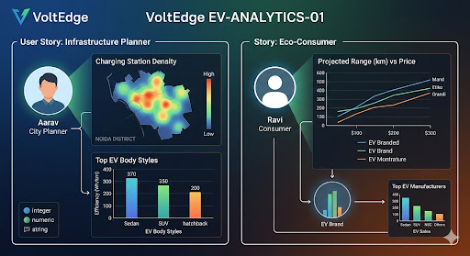
Image Summary: This mockup visualizes the user journey for your personas, with specific charts like the 'Charging Station Density' (Medium Priority User Story USN-3) and 'Price-to-Range' (High Priority User Story USN-2).

